
SPECIALIST MATHS
TRIAL EXAMINATION 2
SOLUTIONS
2013

SECTION 1 – Multiple-choice answers

1. C 7. B 13. C 19. E
2. B 8. D 14. E 20. B
3. E 9. C 15. A 21. D
4. B 10. E 16. C 22. D
5. D 11. A 17. E
6. A 12. D 18. C

SECTION 1- Multiple-choice solutions

Question 1

The graph of 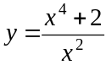 is shown below.
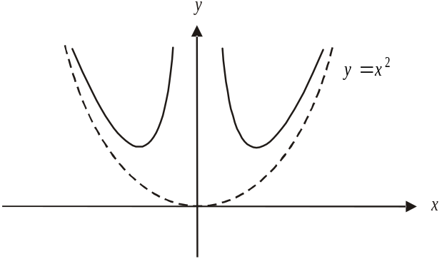

The graph has one straight asymptote , and one curved asymptote 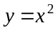.
The answer is C.

Question 2
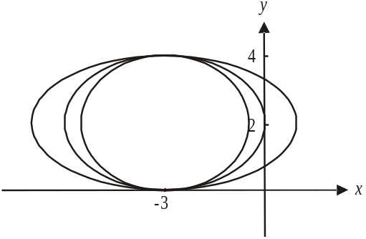
Do a quick sketch.

Since we don’t know the length of the horizontal axis, we have drawn 3 possible ellipses. If the ellipse is to touch the x-axis just once, it will be at the point 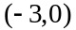 so the length of the vertical semi-axis will be 2.
So .
The answer is B.

Question 3

Do a quick sketch, noting the restricted domain.
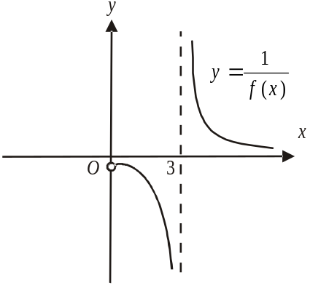

The graph has two asymptotes with equations 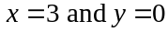. Note that there is local maximum at the point where 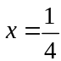 and an excluded endpoint at 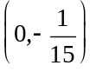.
The answer is E.

Question 4

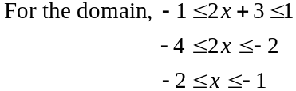
So the domain is 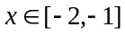.
For the range, start with the range of the function 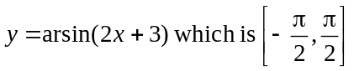.
So the range of the function 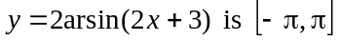 and therefore
the range of the function 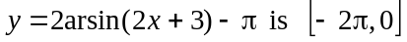.
So the range is 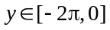.
The answer is B.
Question 5

The period of the graph is 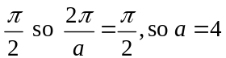.
The graph of 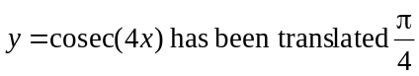 left or right to obtain the graph given in the question so 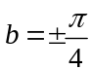.
Only option D gives a correct combination.
The answer is D.

Question 6

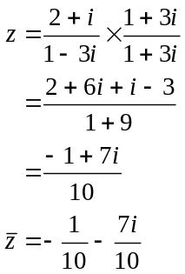
The imaginary part of 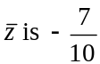.
The answer is A.

Question 7

Let 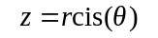
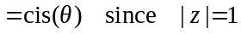
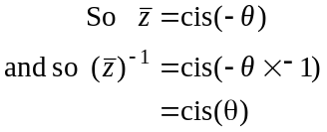
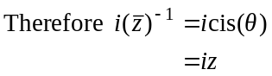
The answer is B.

Question 8

Sketch the region defined by .

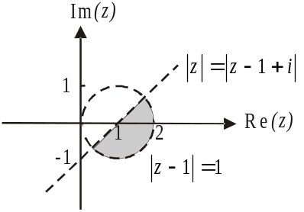

Note that the boundaries are not included so the
complex numbers and 1 do not lie in the region.
The complex numbers i and 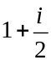 also don’t lie in
the region but the complex number 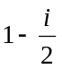 does.
The answer is D.

Question 9

Since 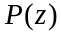 is of degree 6, 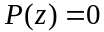 will have 6 roots. Any complex roots must appear in conjugate pairs since the coefficients are real.
It is possible to have all real roots or all complex roots so A and B can be true. It is not possible to have equal numbers of real and complex roots since this would mean 3 complex roots and therefore one complex root at least would not have a conjugate pair.
Two repeated complex roots are fine, for example 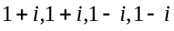(and 2 others) and three repeated real roots are fine also eg. 1, 1, 2, 2, 5, 5.
The answer is C.

Question 10

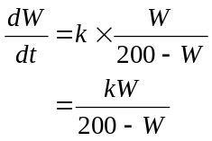
The clue about 5 mice having the disease initially is superfluous here.
The answer is E.

Question 11

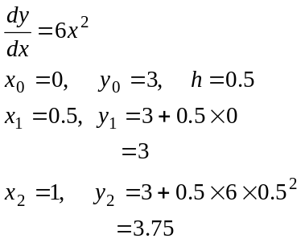
So the value of 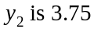.
Since 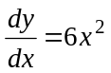, the solution graph will be a positive cubic with a stationary point of inflection on the y-axis at 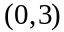 so around , it will be concave up. Therefore the value of 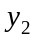 will underestimate 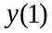,
The answer is A.

Question 12

Along the x-axis and y-axis the gradient is zero so eliminate option E.
For option A, at 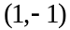 the gradient should be zero which it isn’t so eliminate A.
For option B, at 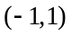 the gradient should be zero which it isn’t so eliminate B.
For option C, at 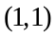 the gradient should be 1 which it is but at , the gradient should be 1 which it isn’t so eliminate C.
The answer is D.

Question 13

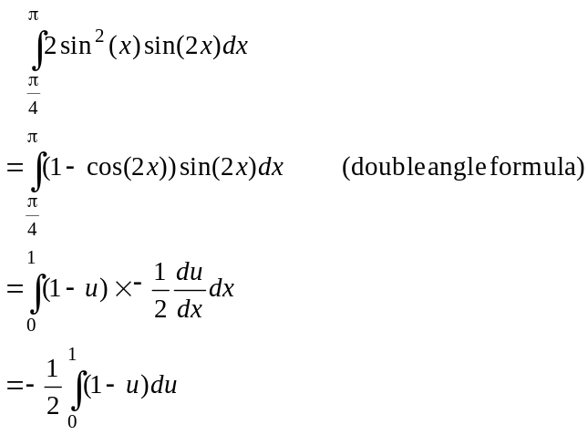
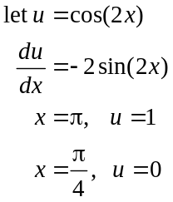
The answer is C.

Question 14

Stationary points occur when 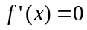 so there are stationary points on the graph of 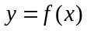 at 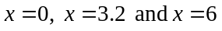. This eliminates options and A and D.
At , there is a local minimum since the gradient goes from negative to positive. This eliminates option B.
At 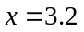 there is a stationary point of inflection since the gradient is positive to the left and right of the stationary point. This eliminates option C.
At 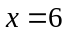 there is a local maximum since the gradient goes from positive to negative.
The answer is E.

Question 15
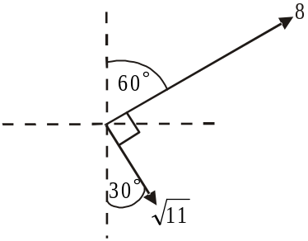
Draw a diagram.

Note that we are only asked for the
magnitude of the resulting force, not
its direction.

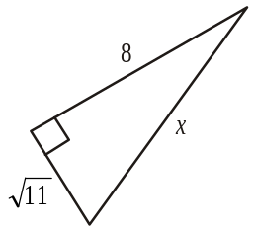
Using Pythagoras,
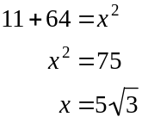
The answer is A.

Question 16

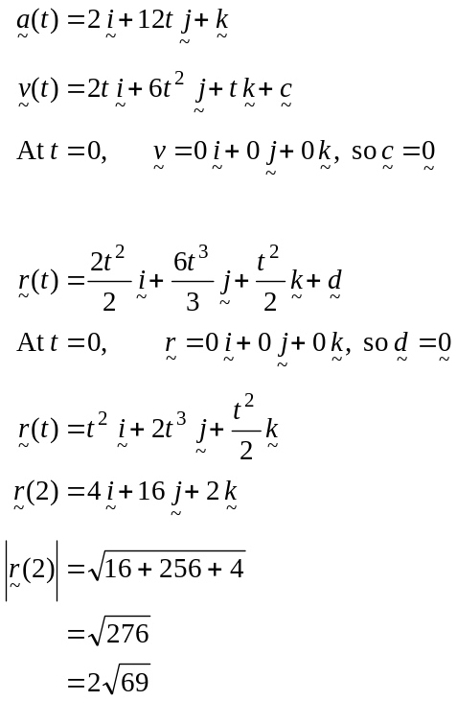
The answer is C.

Question 17

Since 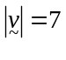
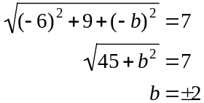

Since 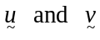 are perpendicular,
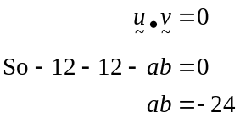

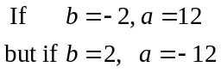

So possible values are
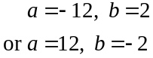
The answer is E.

Question 18

vector resolute of perpendicular to
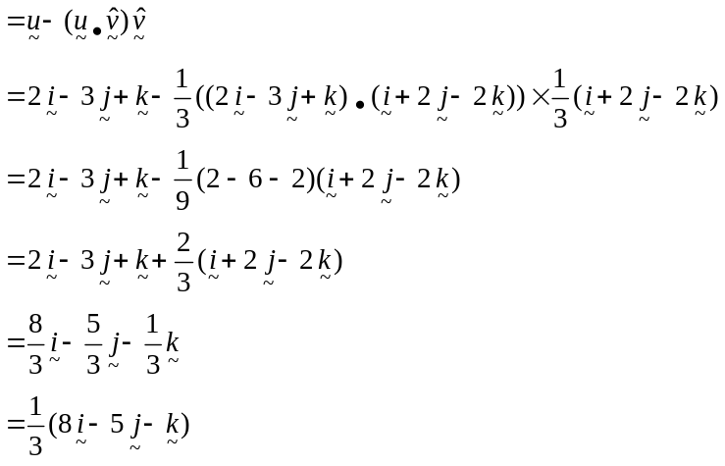
The answer is C.

Question 19

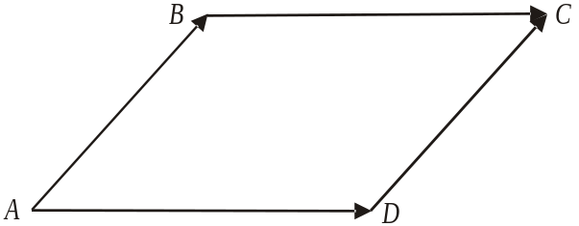

Since ABCD is a parallelogram,
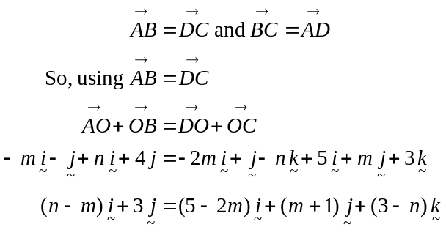

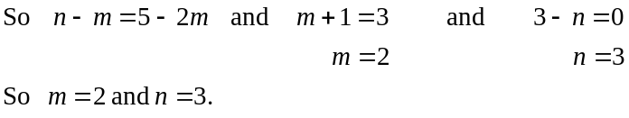
The answer is E.

Question 20

Since acceleration is constant we have

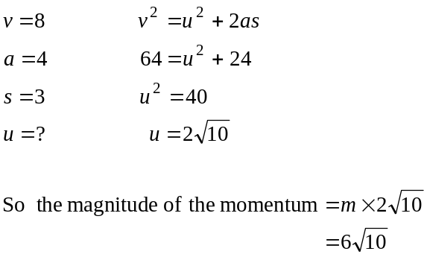
The answer is B.

Question 21

Method 1

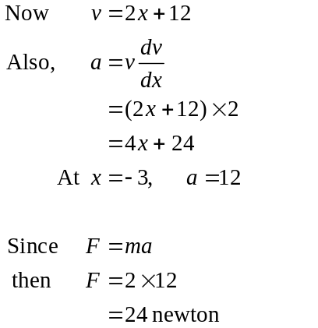
The answer is D.

Method 2

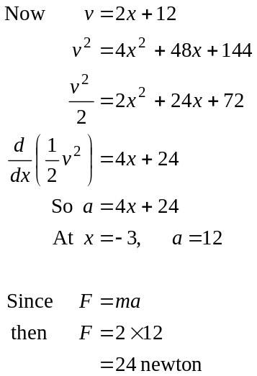
The answer is D.

Question 22
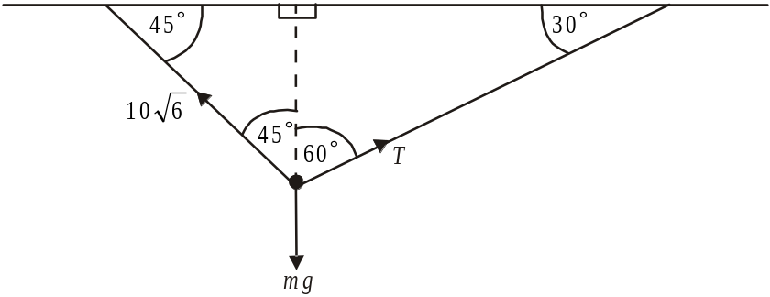

Method 1 – resolving horizontally and vertically

Horizontally,
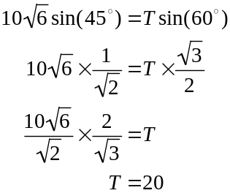
Vertically,
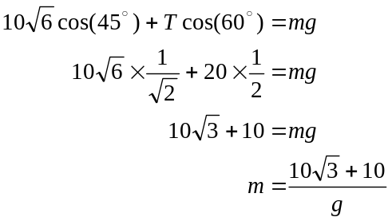
The answer is D.

Method 2 – using Lami’s Theorem

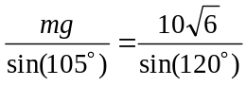

Solve for m using CAS.

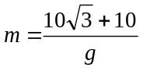

The answer is D.

SECTION 2

Question 1 (12 marks)

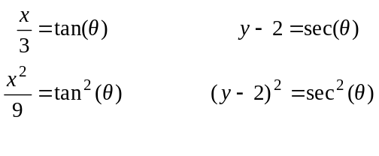
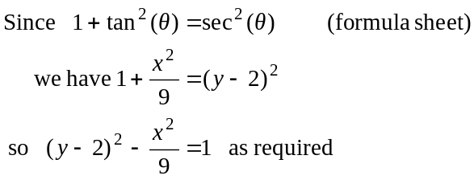
(1 mark)
(1 mark)
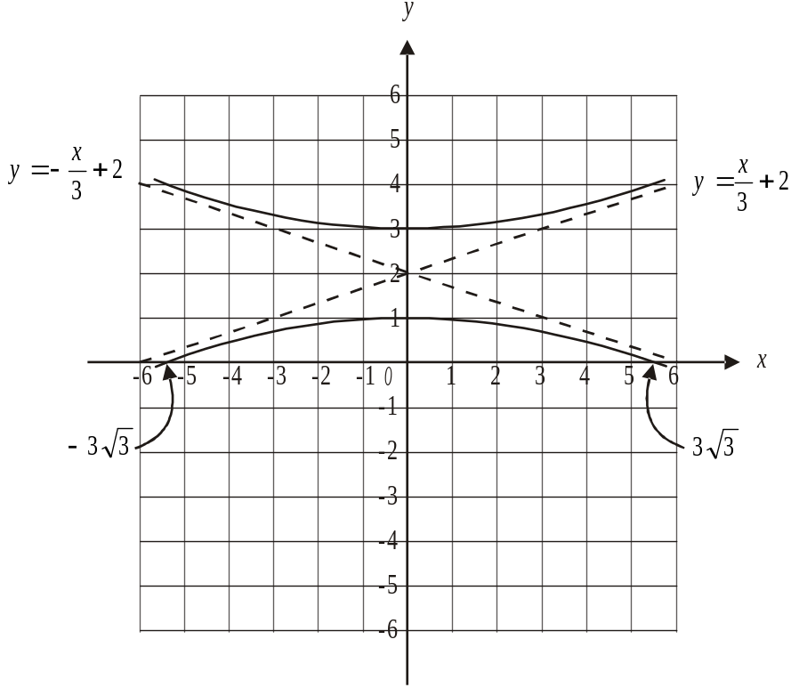

y-intercepts occur when
solve 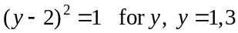
x-intercepts occur when 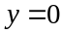
Solve 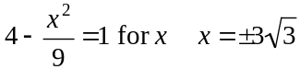
(1 mark) – top branch drawn correctly with y-intercept labelled
(1 mark) – asymptote 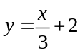 drawn and labelled
(1 mark) – bottom branch drawn correctly and intercepts labelled
(1 mark) – asymptote 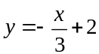 drawn and labelled

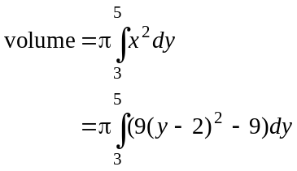
(1 mark)

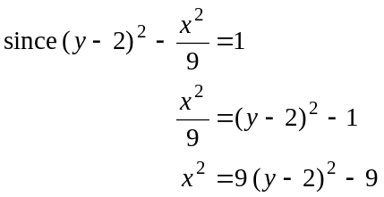

So volume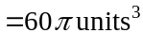 (using CAS).
(1 mark)

- Method 1 – using the Chain rule
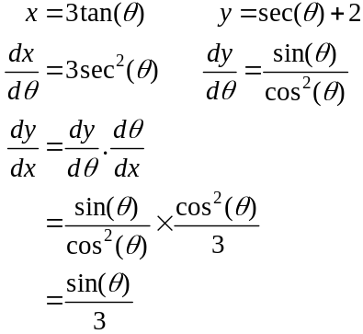
(1 mark)
(1 mark)
Method 2 – using implicit differentiation

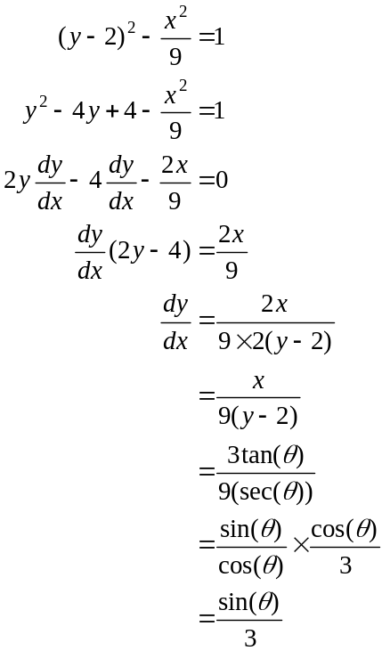
(1 mark)
(1 mark)

- 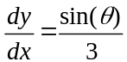 from part d.
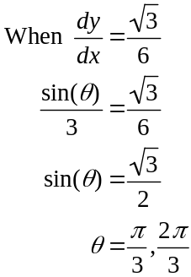
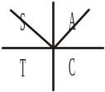
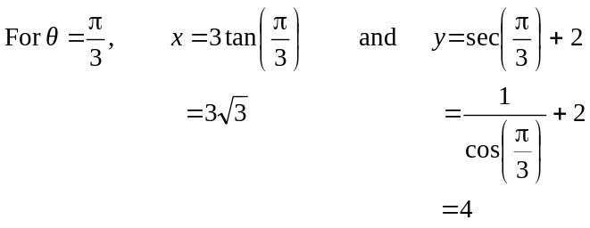

One of the points is 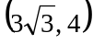.
(1 mark)

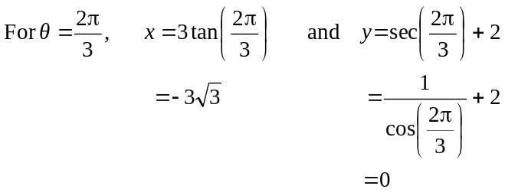
(1 mark)
The other point is 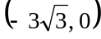.

If you have time, check the feasibility of these two points by looking at your graph and/or making sure they satisfy the Cartesian equation.

Question 2 (12 marks)

- At , 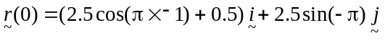
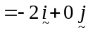
(1 mark)
Since the ticket office is located at 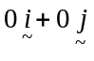, the train starts its journey 2 km due west of this.
(1 mark)
- a is the time taken for the train to complete one circuit of the track.

Method 1
From part a. we know that the train starts at 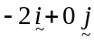.
Solve 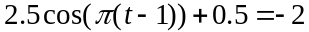 for t to find the next time that the train is at this point. (1 mark)
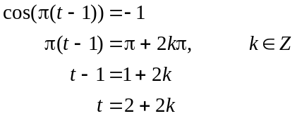
So the next time is at .
So it takes 2 hours to complete a circuit of the track and so 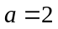.
(1 mark)
Method 2
Since both the cos function and the sin function have a period of 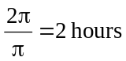, the path repeats after 2 hours. (1 mark)
So it takes 2 hours to complete a circuit of the track and so .
(1 mark)
- 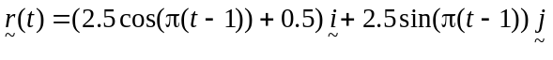
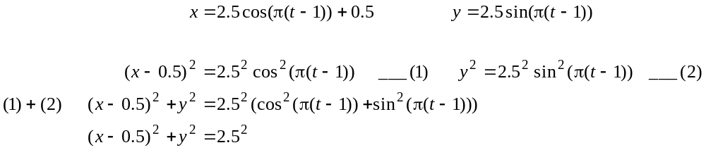 (1 mark)
(1 mark)
- 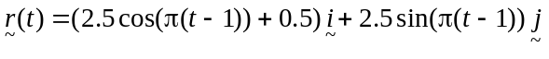
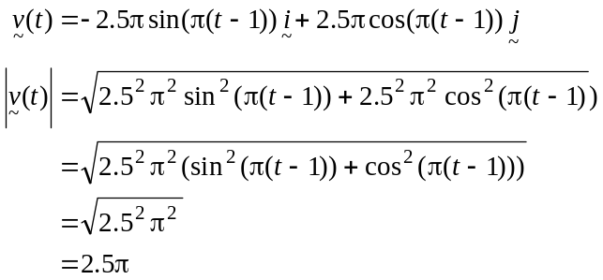
(1 mark)
(1 mark)
So speed is constant; that is km/hr.
- Since the road runs due north of the ticket box, the train will intersect with the road when
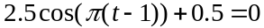
(1 mark)
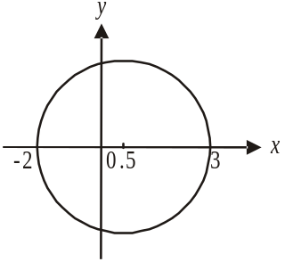

Solve for t.
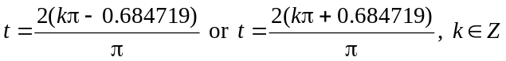

From the diagram, we want the second lowest positive value of t. Note that the first lowest positive value of t gives the time it takes for the train to come to a road running south from the ticket box. This is because the train starts at the point 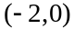 and travels anticlockwise in a circle. (Check this by finding 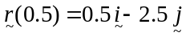 for example, and from part b, a whole circuit takes 2 hours).

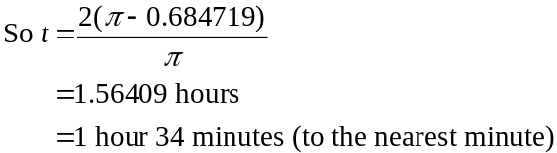
(1 mark)

- The distance of the train from the ticket office is given by

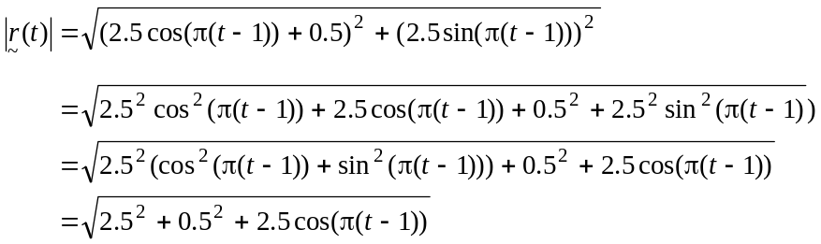
(1 mark)
So maximum occurs when 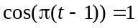
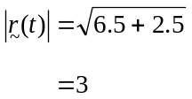
Furthest distance is 3km.
(1 mark)

Question 3 (12 marks)

- Since acceleration is constant, we can use the constant acceleration formulae.
We have,
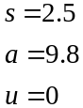
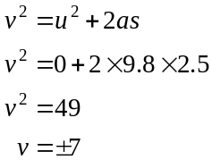
So the speed is 7 ms⁻¹.
(1 mark)

- i. Again we have constant acceleration.
When it hits the ground, 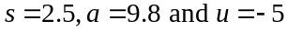.
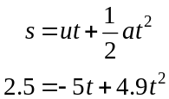
(1 mark)
Solve for t.
secs (correct to one decimal place). (1 mark)

- Using
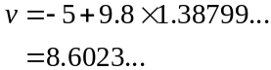
So the speed is 8.6 ms⁻¹ (correct to one decimal place).
(1 mark)

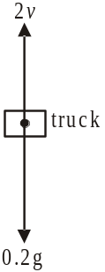

(1 mark)

- Since acceleration is directed downwards, we have,

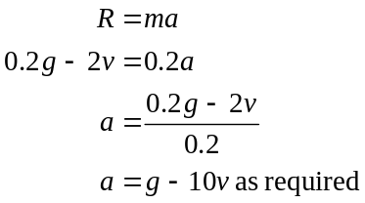
(1 mark)

e. 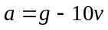
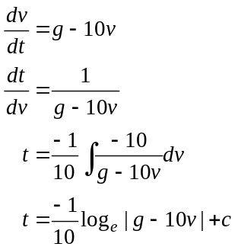
(1 mark)

When 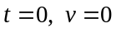
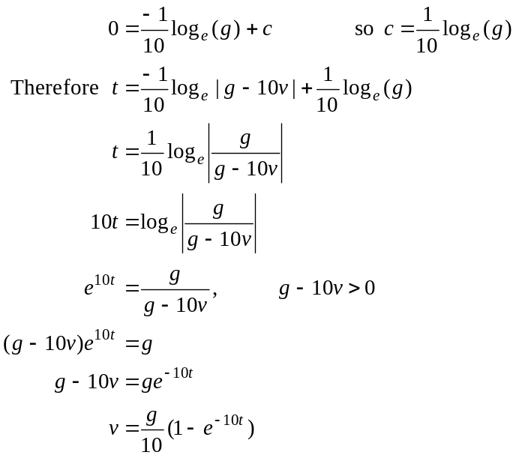
(1 mark)
(1 mark)
as required

- Do a quick sketch of the velocity function 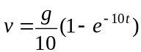.
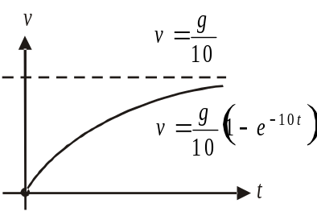

The limiting velocity is 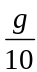.
(1 mark)
Alternatively, as 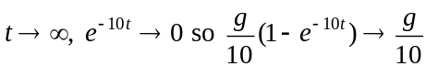.

- 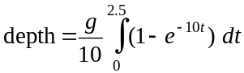
(1 mark)
metres (correct to 1 decimal place)
(1 mark)

Question 4 (11 marks)

- Solve for t.
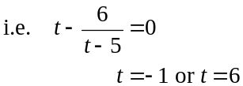
Since k is a positive constant, .
(1 mark)

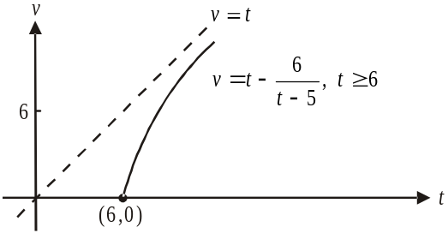

The graph of 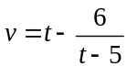 has two asymptotes with equations .
Since the domain for this function is , we can leave out the vertical asymptote.
(1 mark) – correct asymptote
(1 mark) – correct shape including endpoint

- From the graph, there is an oblique asymptote with equation . Therefore the gradient of the graph; that is, the acceleration of the car, approaches 1 ms⁻² as .
(1 mark)

- Again, from the graph, solve 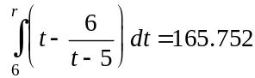 for r using CAS.
(1 mark)
So .
So 20 secs after the light went green Ashleigh noticed the police.
(1 mark)

- 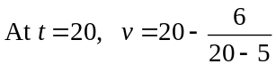
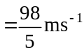
(1 mark)

- i. 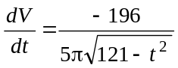
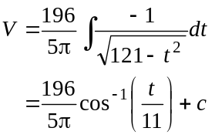
So 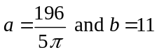. (1 mark)

When 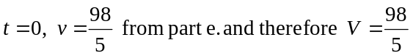.

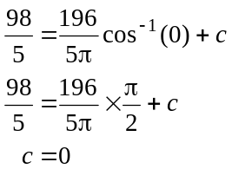
(1 mark)

- Note that it takes 11 secs for Ashleigh’s car to come to rest i.e. solve
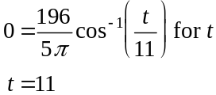

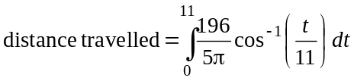 (1 mark)

So (correct to 1 decimal place).
(1 mark)

Question 5 (11 marks)

- Since 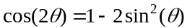,
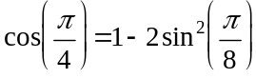
(1 mark)
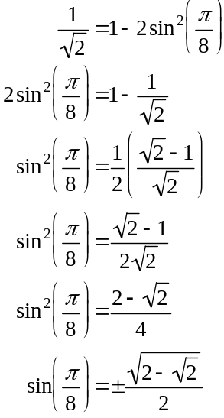
(1 mark)
Since 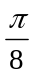 is a first quadrant angle 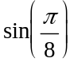 is positive.
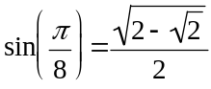
(1 mark)
as required.

- 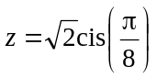
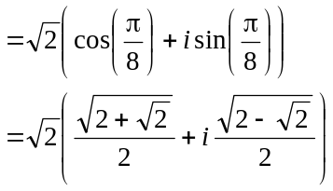
(1 mark)

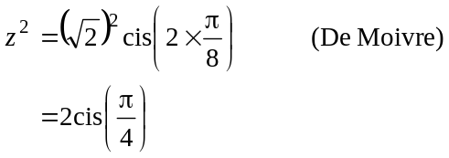
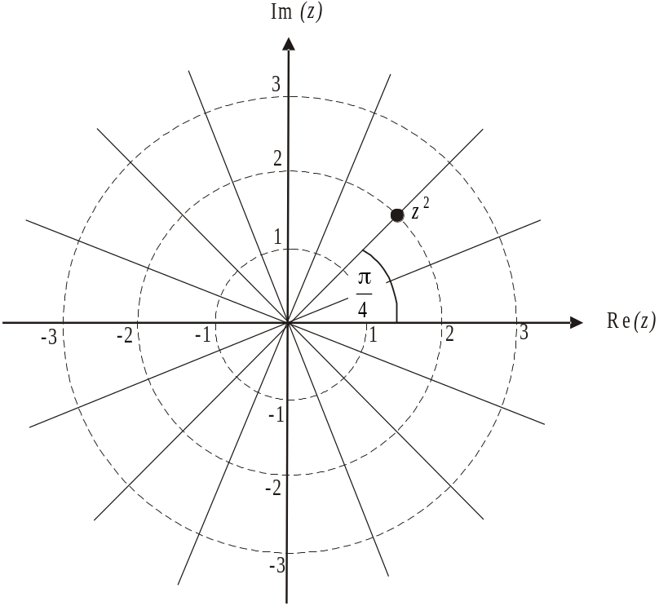

(1 mark)

- From part c., 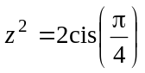
so 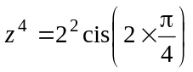 (De Moivre again)
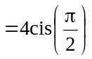
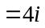 (1 mark)
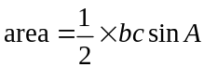
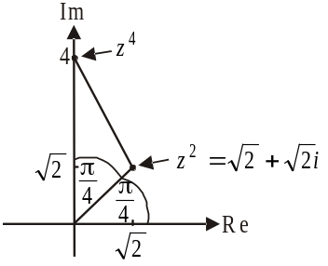
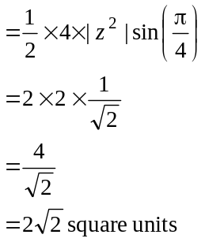
(1 mark)

- i.
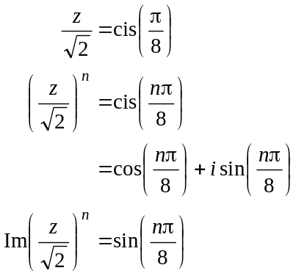
(1 mark)
Solve 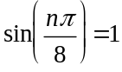 for n
(1 mark)
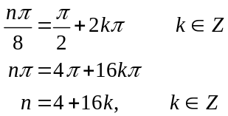
(1 mark)

- 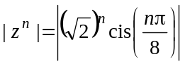
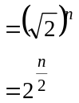
Since 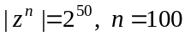
(1 mark)
(Check, using your answer to part i., that this is a feasible answer; that is, can ? Yes, 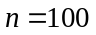 when ).

